# Question 1 exercices:

**Exercise 1.1 Create another circle. Then create a square.**

* After creating 2 circles and one square and calling method makeVisible () on circle1:

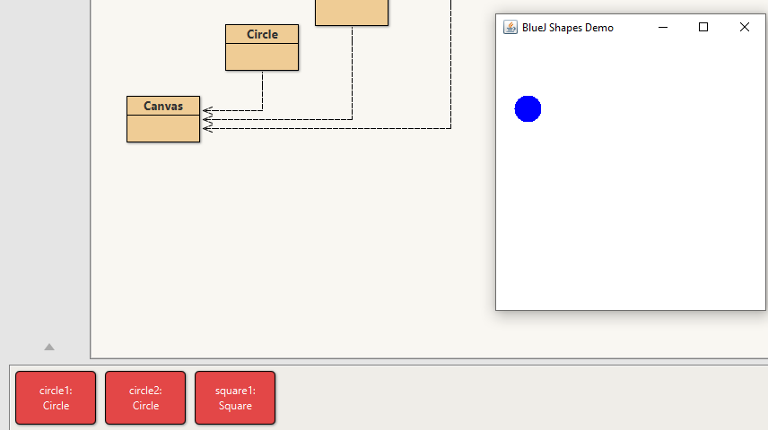

* After calling methods moveDown() and moveRight() many times on circle1:

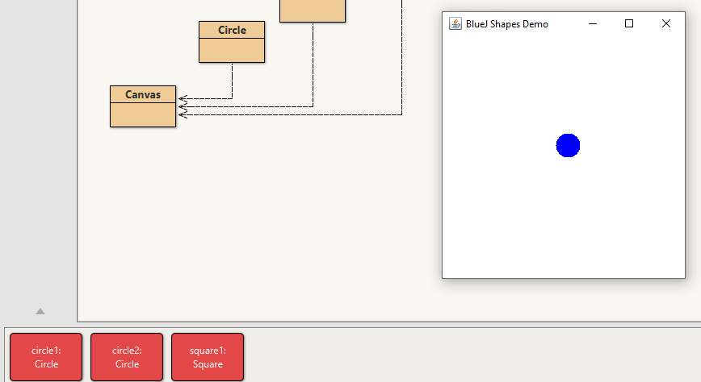

**Exercise 1.2 What happens if you call moveDown twice? Or three times? What happens if you call makeInvisible twice?**

* After calling moveDown() twice the circle moves vertically 40 px down as shown in the next first picture, and after calling makeInvisible()e twice the circle disappears from the screen as shown in the second picture:

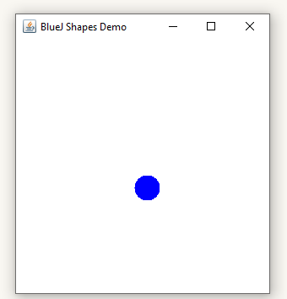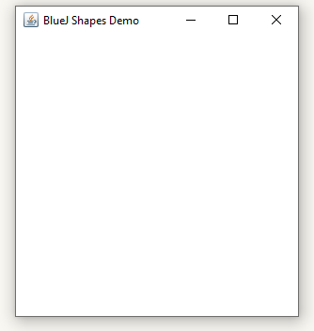

**Now invoke the moveHorizontal method. You will see a dialog appear that prompts you for some input (Figure 1.4). Type in 50 and click Ok. You will see the circle move 50 pixels to the right.**

**Exercise 1.3 Try invoking the moveVertical, slowMoveVertical, andchangeSize methods before you read on. Find out how you can use moveHorizontal to move the circle 70 pixels to the left.**

* After calling moveHorizontal(50) :

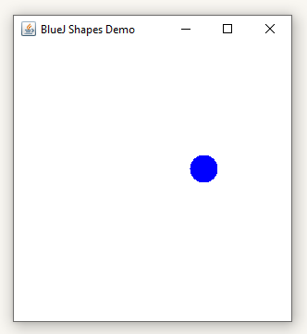

* After calling and then moveVertical(-70) andmove moveHorizontal(-50):

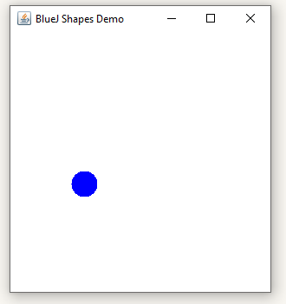

**Exercise 1.4 Invoke the changeColor method on one of your circle objects and enter the String “red”. This should change the color of the circle. Try other colors.**

After calling changeColor("red") and changeColor("magenta") :

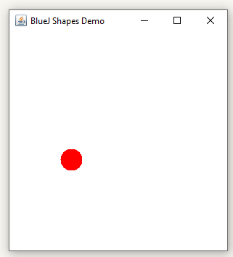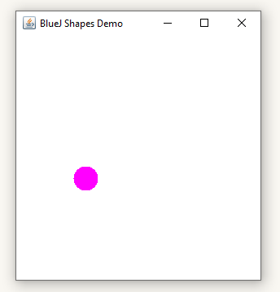

**Exercise 1.5 This is a very simple example, and not many colors are supported. See what happens when you specify a color that is not known.**

* After trying changeColor("cyan") the circle becomes black as shown in the next picture:

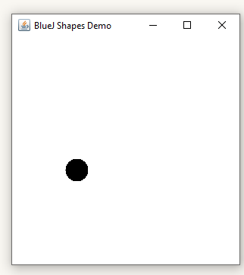

**Exercise 1.6 Invoke the changeColor method, and write the color into the parameter**

**field without the quotes. What happens?**

* An error accurs as shown in the next picture:

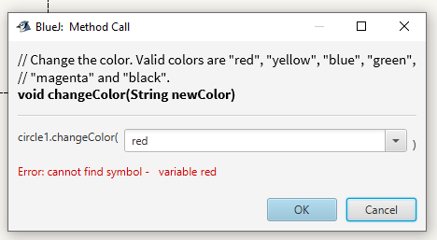

**Exercise 1.7 Create several circle objects on the object bench. You can do so by selecting new Circle() from the popup menu of the Circle class. Make them visible, then move them around on the screen using the ‘move’ methods. Make one big and yellow, make another one small and green. Try the other shapes too: create a few triangles and squares. Change their positions, sizes, and colors.**

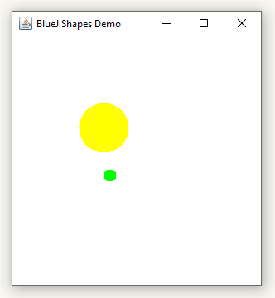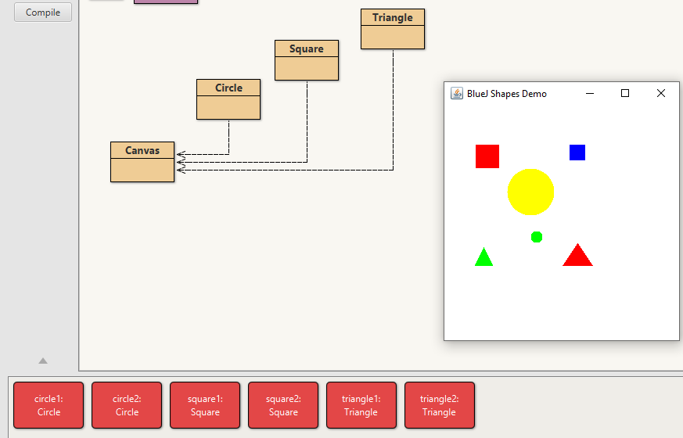

**Exercise 1.8 Make sure you have several objects on the object bench and then inspect each of them in turn. Try changing the state of an object (for example by calling the moveLeft method) while the object inspector is open. You should see the values in the object inspector change.**

* Before moving objects we can see this picture of the object inspector for circle1 , square1 and triangle1 :

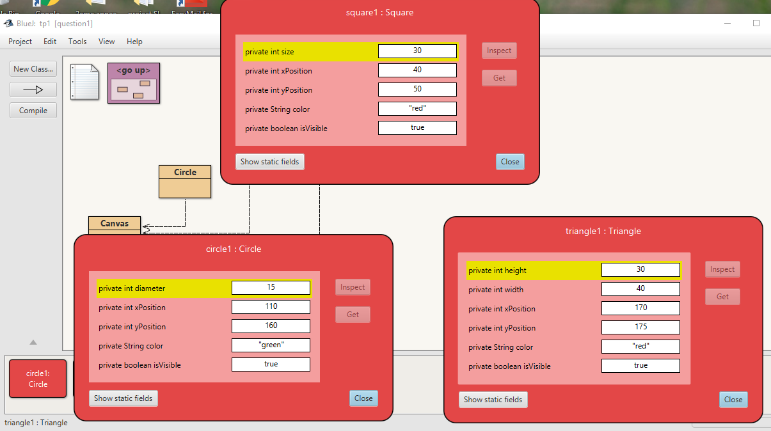

* After calling moveVertical(20) on square1 for example , we can see that the variable yPosition in square1 changes from 50px (in the first screenshot ) to 70px in the second screenshot :

